1. [SELECT](http://localhost/phpmyadmin/url.php?url=https://dev.mysql.com/doc/refman/8.0/en/select.html" \t "mysql_doc) tanggal,faktur\_supply.id\_karyawan,karyawan.nama FROM `faktur\_supply` JOIN karyawan ON faktur\_supply.id\_karyawan = karyawan.id ORDER By karyawan.nama;

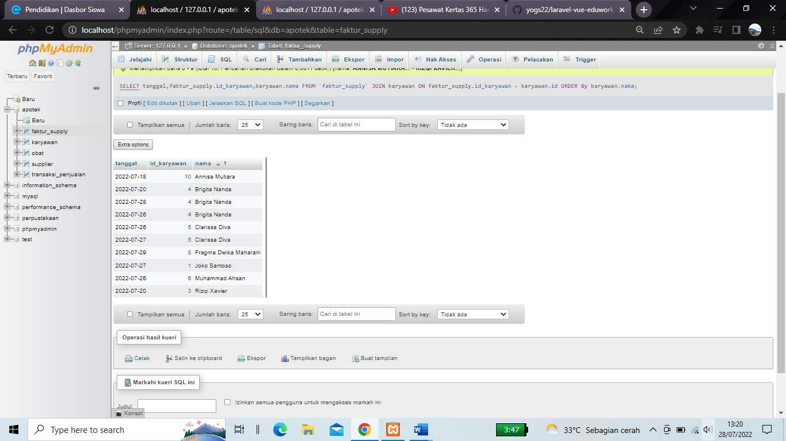

1. [SELECT](http://localhost/phpmyadmin/url.php?url=https://dev.mysql.com/doc/refman/8.0/en/select.html) tanggal,faktur\_supply.id\_karyawan,karyawan.nama, karyawan.alamat FROM `faktur\_supply` JOIN karyawan ON faktur\_supply.id\_karyawan = karyawan.id WHERE karyawan.alamat [LIKE](http://localhost/phpmyadmin/url.php?url=https://dev.mysql.com/doc/refman/8.0/en/string-comparison-functions.html%23operator_like) '%yogyakarta%' ORDER By karyawan.nama;

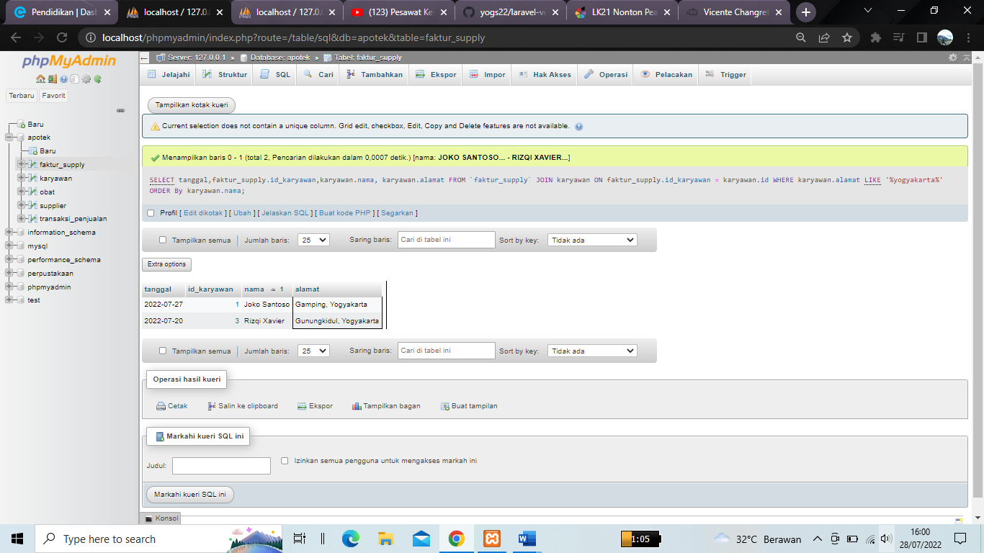

1. [SELECT](http://localhost/phpmyadmin/url.php?url=https://dev.mysql.com/doc/refman/8.0/en/select.html) tanggal,faktur\_supply.id\_karyawan,karyawan.nama FROM `faktur\_supply` [RIGHT](http://localhost/phpmyadmin/url.php?url=https://dev.mysql.com/doc/refman/8.0/en/string-functions.html%23function_right) JOIN karyawan ON faktur\_supply.id\_karyawan = karyawan.id ORDER By karyawan.nama;

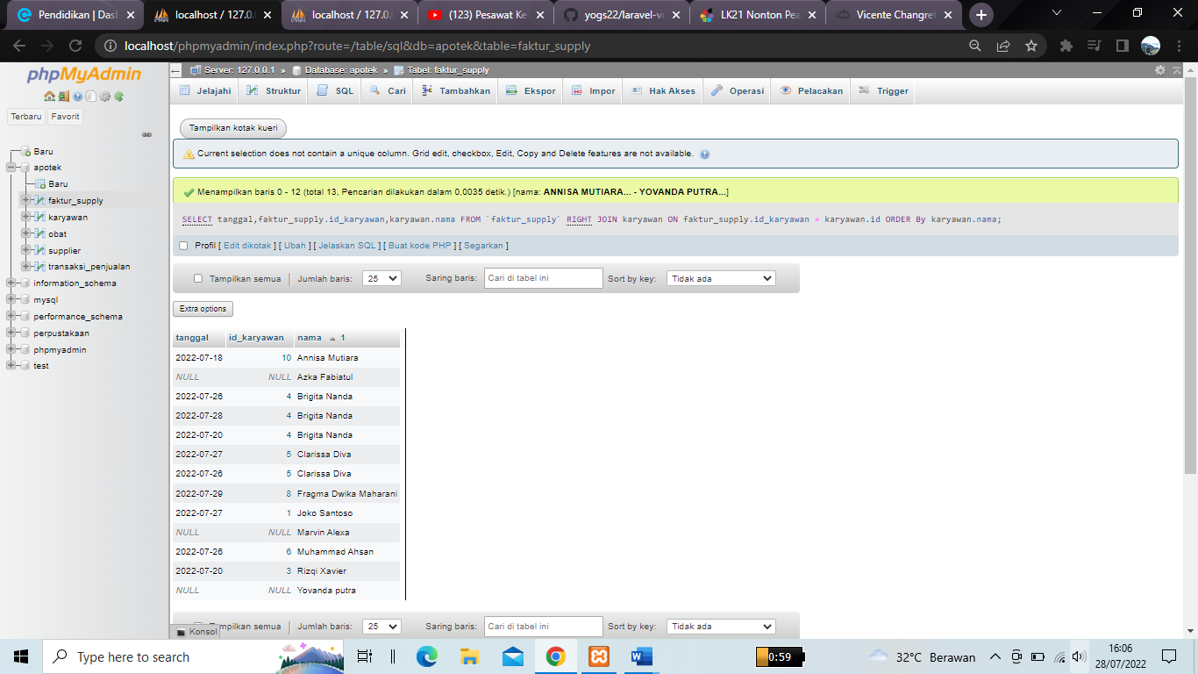

1. [SELECT](http://localhost/phpmyadmin/url.php?url=https://dev.mysql.com/doc/refman/8.0/en/select.html) tanggal,faktur\_supply.id\_karyawan,karyawan.nama,karyawan.alamat FROM `faktur\_supply` [LEFT](http://localhost/phpmyadmin/url.php?url=https://dev.mysql.com/doc/refman/8.0/en/string-functions.html%23function_left) JOIN karyawan ON faktur\_supply.id\_karyawan = karyawan.id ORDER By karyawan.nama;

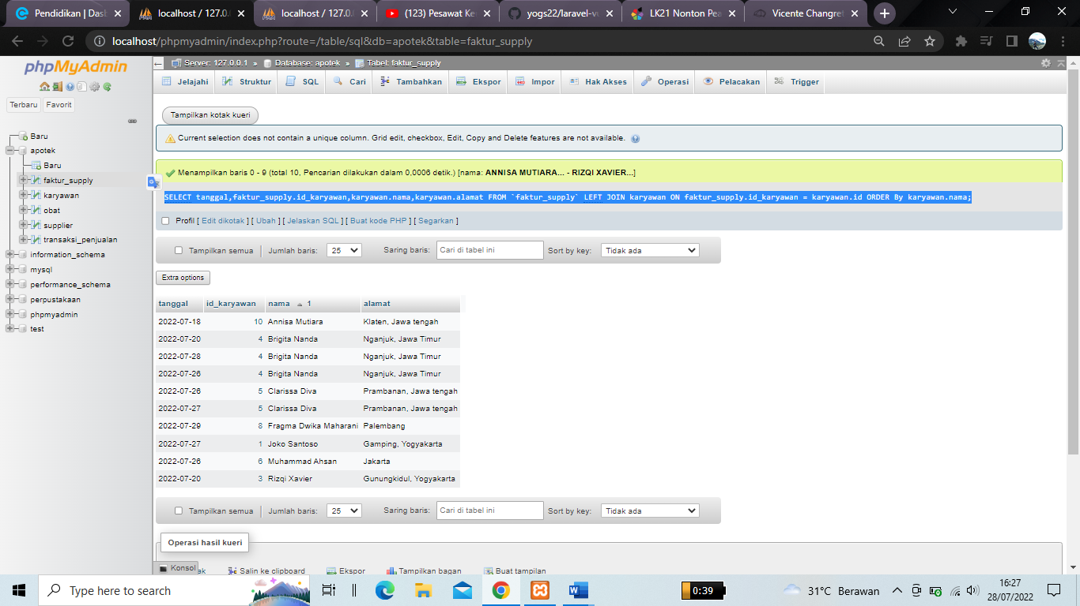

1. [SELECT](http://localhost/phpmyadmin/url.php?url=https://dev.mysql.com/doc/refman/8.0/en/select.html) tanggal,transaksi\_penjualan.id\_karyawan,karyawan.nama,nama\_customer,jumlah\_order FROM transaksi\_penjualan [RIGHT](http://localhost/phpmyadmin/url.php?url=https://dev.mysql.com/doc/refman/8.0/en/string-functions.html%23function_right) JOIN karyawan ON transaksi\_penjualan.id\_karyawan = karyawan.id WHERE nama\_customer [IS](http://localhost/phpmyadmin/url.php?url=https://dev.mysql.com/doc/refman/8.0/en/comparison-operators.html%23operator_is) [not](http://localhost/phpmyadmin/url.php?url=https://dev.mysql.com/doc/refman/8.0/en/logical-operators.html%23operator_not) null [AND](http://localhost/phpmyadmin/url.php?url=https://dev.mysql.com/doc/refman/8.0/en/logical-operators.html%23operator_and) jumlah\_order >= 2 ORDER By karyawan.nama;

